MT455 Sales PlaN
Final Project
Name: _____________________Date: __________

Executive Summary

Provide an executive summary. An executive summary is a summary for busy executives that provide highlights of the key points in your project. Your executive summary should consist of approximately two paragraphs.

Sales Plan

Provide an introduction to the project. Give the reader an overview of what the project is about. Be sure to double space your work and give credit where credit is due by citing your sources according to APA guidelines.
Overview of the Organization and its Mission
In this section, discuss the organization you have selected. Provide an overview of the
organization and its mission.
Company’s Core Products or Services
Identify the company’s core products or services.
Target market
In this section, determine the target market including demographics, location, and size of the target market.
Sales objectives
Discuss the organization’s sales objectives.
Ethics
Discuss the role business ethics play in the sales organization.

Business Strategy
In this section, discuss the business strategy for the organization you have selected. Determine the markets they are pursuing. Discuss whether the organization is expanding, retracting, adding new products, etc.?
Competitive Environment
Identify the company’s primary competitors describe the top three competitors, if applicable.
Competitive Advantage
Describe the organization’s competitive advantage.
Relationship Strategy
Discuss the type of relationship strategy the company uses for example functional relationships, strategic partnerships, market exchanges etc.
Organizational Structure
Provide an analysis of how the organization you have selected is structured. Create an organizational chart beginning at the top (See the basic example below, be aware that not all levels are represented, this is for illustrative purposes only). Describe whether there are vice presidents and who reports to them (such as general or regional managers) and then who reports to them and so forth.
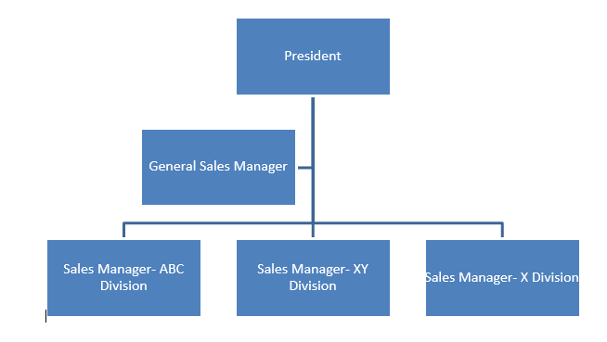Organization of Sales Force
Determine whether the organization is structured by product, geography, customer type, selling function, or by type of customer. Refer to Chapter 6 of Cron and DeCarlo (2009) for guidance.
Sales Force
Discuss the sales channels used to sell the products or services. Are both inside and outside representatives employed. Discuss whether the company uses their own sales force or if they have outsourced the sales force through the use of agents, do they sell over the internet, or via catalog? What role does telemarketing play in the company’s sales force? How are national or key accounts handled? Is team selling used?

Territory Design
Analyze the sales territories, and the most appropriate sales forecasting method. Evaluate the organization’s territory design. Is the company using the most optimal territory design? Discuss the size of the sales force.

Sales Forecasting
Discuss what forecasting method would be most appropriate for the organization and explain why. Consider the advantages and disadvantages of the primary sales forecasting methods. Be sure to review concepts covered in Chapter 2 Pages 59 - 86 of Cron and DeCarlo (2009) for guidance. If possible provide a chart or table with a sales forecast for the organization. Be sure to explain the assumptions used to make the forecast. See the example below.
Sales Forecast for 2 years:
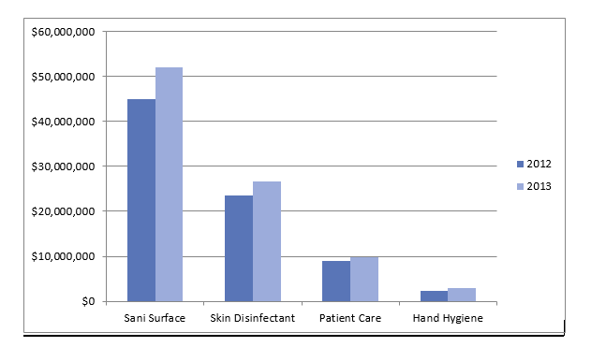
Note. This table demonstrates (be sure to explain the values used in your table).
Recruiting
Discuss the resources required to recruit sales people. What are the sources for new sales recruits? Discuss the knowledge skills and abilities required for the sales position. Be sure to review concepts covered in Chapter 7 of Cron and DeCarlo (2009) for guidance.
Selection
Discuss the methods for deciding on selection criteria. Define appropriate selection procedures.
Training
Discuss the best initial and refresher training sales method. Address the key issues in sales training, identify the training objectives, define the topics covered in a sales training program, and discuss the various methods for conducting sales training. Be sure to review concepts covered in Chapter 8 of Cron and DeCarlo (2009) for guidance.
Training Budget
Discuss the best way to measure the costs and benefits of sales training. Determine the training budget for one year. Use the sample training budget chart below for ideas.
Training Session | Method: Internal or External | Frequency | Trainees per year | Training Costs | Cost per Trainee
Initial Sales |  | By position | X | $xxx | $x
Refresher Training |  | Quarterly | X | $xxx | $x
Annual Total Budget |  |  | X | $xxx | $xxx
Note. (Explain basis for your table, clarify anything the reader may not understand)

Conclusions and Observations
Determine sales leadership strategies to keep the sales force motivated to maintain high levels of performance. Discuss the strengths of the sales plan and any area of improvement.

References
Cron, W. L. & DeCarlo, T. E. (2009). Dalrymple's sales management: Concepts and cases (10th ed.). New York, NY: The McGraw-Hill Companies, Inc.

Note: Include a reference list on a separate page. Be sure you cite your sources in the body of your work and use your reference list to include all sources you used. Refer to the APA manual for guidance.

