**Unit 6 Discussion Board**

1. Fill in the chart below by accessing the Google doc. Instructions on how to access to a Google doc are available from your instructor.

|  |  |  |  |
| --- | --- | --- | --- |
| **Name** | **Height (x)** | **Shoe Size (y)** | **Data Point (x, y)** |
| **Armando Solis** | 65 | 9 | (65, 9) |
| **Bill Dambeck** | 62 | 8 | (62, 8) |

1. 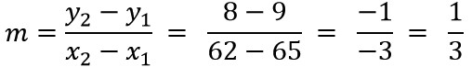Plot the two data points from above and draw the line connecting them. Note: Be aware that the scale of the x-axis and the scale of the y-axis are not the same. Watch the video in [LiveBinder](http://www.livebinders.com/play/play?id=1636969) if you need help drawing a line.

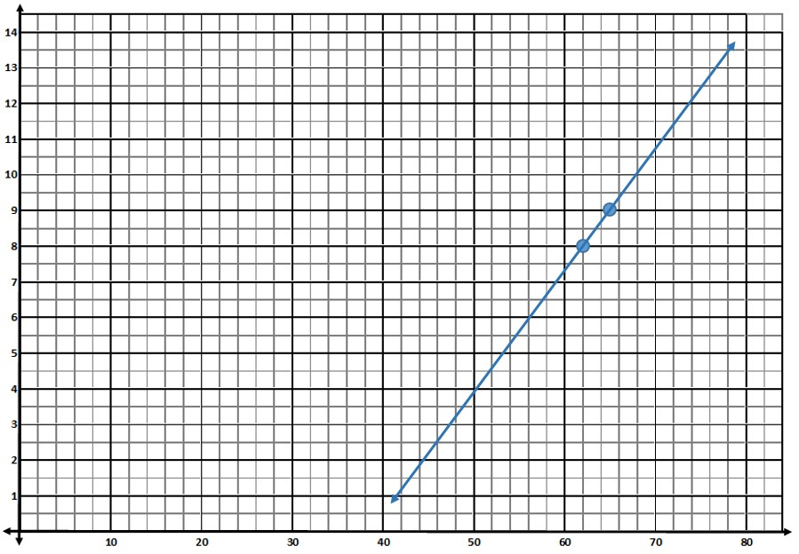

1. Find the slope of the line between your two data points. You may show the work here, but it must also be posted in your reply on the DB.