**Unit 6 Discussion Board**

*1. Fill in the chart below by accessing the Google doc. Instructions on how to access to a Google doc are available from your instructor.*

|  |  |  |  |
| --- | --- | --- | --- |
| Name | Height (x) | Shoe Size (y) | Data Point (x, y) |
|  |  |  |  |
|  |  |  |  |

*2. Plot the two data points from above and draw the line connecting them. Note: The x-axis counts by 2’s. Please see the video in Unit 6 LiveBinder for help drawing a line.*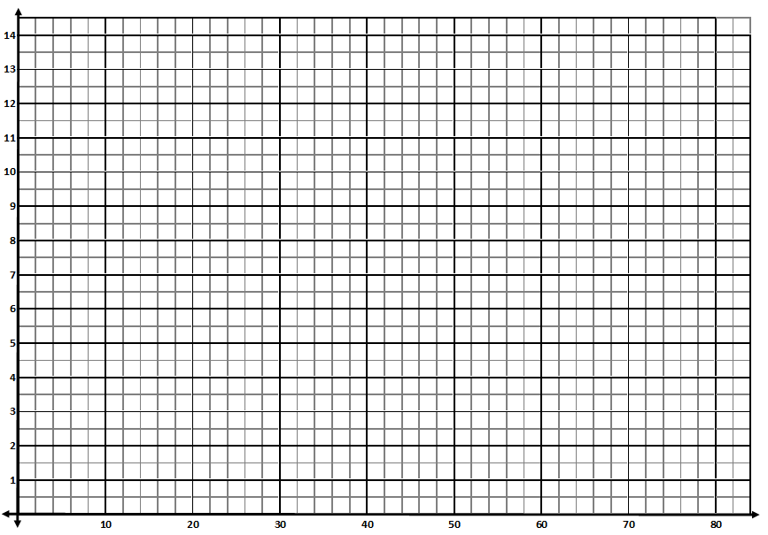

*3. Find the slope of the line between your two data points. You may show the work here, but it must also be posted in your reply on the DB.*

*4. Save this document and attach it to your reply for Part 1 on the Discussion Board.*