GSB SPECIFIC ANNOUNCEMENT:
- Moving your study portfolio from Foliotek to Optimal Resume
  - Export your Foliotek site and save it to your computer (need to document this)
  - Create an account in Optimal Resume using the “Creating a New Account” instructions
  - Upload your first file from your saved Foliotek site on your computer using the “Uploading my First Assignment” instructions
  - Upload the remainder of your files using the “Uploading Files to Optimal Resume” instructions
STUDENT STUDY PORTFOLIO USER GUIDE:
- Creating your new account:
  - Go to https://kaplanu.optimalresume.com/, the Kaplan University Optimal Resume website will load
  - Click on the “Create New Account” button in the top left hand corner of the site and the Validation page will load
  - Enter your Kaplan University email address (it should be in the format user_id@student.kaplan.edu) into the field toward the foot of the page and click on the Continue button when complete and the Code Validation page will load
  - Double check that the email address you entered is correct when it is displayed in bold on the Code Validation page, if it was not correct then you will need to go back, re-enter your email and click continue again
  - Open your Kaplan University email account and you should have received an email from Optimal Resume providing you with an access code
  - Re-enter your email address and enter the access code into the fields provided
  - Click on the submit button to continue and complete the registration process.

- Accessing your account:
  - Go to https://kaplanu.optimalresume.com/, the Kaplan University Optimal Resume website will load
  - Enter your Kaplan University email address and password into the fields provided in the upper right hand side of the site, if you do not have an account in Optimal Resume please create one using the “Creating a New Account in Optimal Resume” instructions
  - Click on the Login button, when logged in you will be presented with your Document Center so you can start work in Optimal Resume

- Uploading your first assignment:
  - Log into Optimal Resume using the “Accessing an Existing Account in Optimal Resume” instructions
  - Create your Study Portfolio:

- Click on the “Create New Portfolio” link toward the top of the Portfolios section in your Document Center and the new portfolio wizard will load;
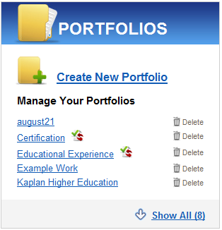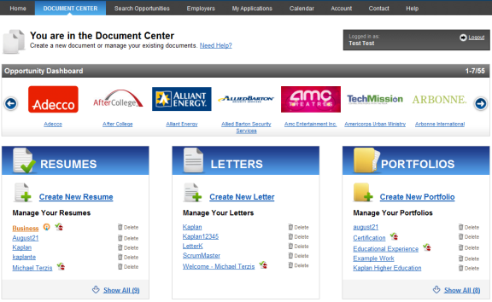
- Enter the name of your program’s study portfolio in the following format: “Study - <Insert your Program Name here>”, e.g. “Study – MBA”
- Click on the “Start Portfolio” button to the right of the field when complete, you should see the name of your portfolio appear towards the top of the “Add New Project” screen

  - Create your first Project:

NOTE: Projects are used to subdivide Portfolios in Optimal Resume, please refer to your school’s specific requirements for recommendations on naming conventions and study portfolio structure so that your items are easy to find.

- Enter the name of your first project
- Enter a description for your first project
- Click “Continue / Add Files” and the Add File screen will appear

  - Adding your first File:

- Browse for the file and select it to upload, the file path will appear in the grayed out field
- Enter a short name for the file and a description of the unique skills and abilities that this file reflects

Tips, use:
    - Short filenames to improve usability
    - The Description field to explain the unique skills and abilities that your file reflects
    - The Special Viewing Requirements field to let users know if specific software is needed to view your file

- Click “Save File” at the bottom of the screen and your newly created Portfolio complete with the Project and File will load

- Adding a File to an existing Project:

  - Click “Add Files” in the links toward the top right of the Portfolio screen and the Add Files screen will load:
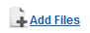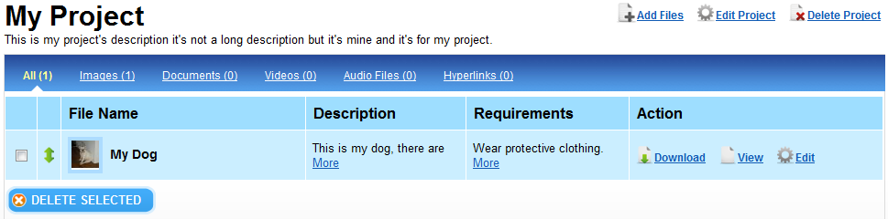
  - Browse for the file and select it to upload, the file name will appear onscreen
  - Enter a name and description for your file

Tips, use:
    - Short filenames to improve usability
    - The Description field to explain the unique skills and abilities that your file reflects
    - The Special Viewing Requirements field to let users know if specific software is needed to view your file

  - Click “Save File” at the bottom of the screen and your new file will show within your Portfolio on the Portfolio screen

- Creating a new Project within an existing Portfolio:

  - Click the “Add Project” button toward the top right of the Portfolio screen and the Add New Project screen will appear

NOTE: Projects are used to subdivide Portfolios in Optimal Resume, please refer to your school’s specific requirements for recommendations on naming conventions and study portfolio structure so that your items are easy to find.

- Enter the name of your first project
- Enter a description for your first project
- Click “Continue / Add Files” and the Add File screen will appear

- Submit my study portfolio for instructor review:

  - To submit your open Portfolio for review click on the “Review Center” button in the horizontal navigation bar that is toward the top of the Portfolio screen and the Review Center should expand:
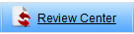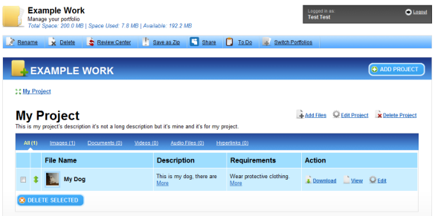

  - From the Reviewer Group select? and from Reviewer select the name of your Instructor, if you would like to leave a message enter it into the message field and this will be posted to your Instructor, click Submit when you are ready and it will be submitted for review. Once submitted you will see the Status History and Messages areas so that you can monitor the feedback provided and communicate with your Instructor:
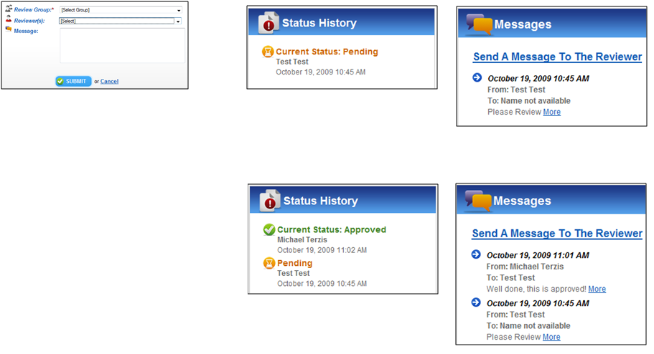
1.Submit
2. Instructor Reviews and leaves feedback

